**STATIC BLOCKS AND STATIC METHODS:**

**class** StaticBlock {

**public** **static** **void** main(String[] args) {

System.out.println("Main method is executed.");

}

**static** {

System.out.println("Static block is executed before main method.");

}

}

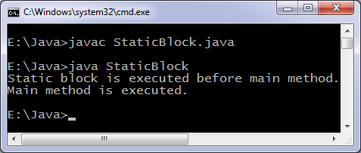

**class** StaticBlock {

**public** **static** **void** main(String[] args) {

System.out.println("You are using Windows_NT operating system.");

}

**static** {

String os = System.getenv("OS");

**if** (os.equals("Windows_NT") != **true**) {

System.exit(1);

}

}

}

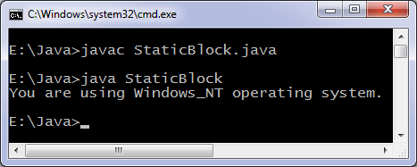

**class** Languages {

**public** **static** **void** main(String[] args) {

display();

}

**static** **void** display() {

System.out.println("Java is my favorite programming language.");

}

}

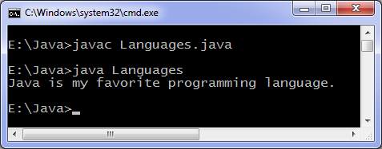

**Java static method vs instance method**

**class** Difference {

**public** **static** **void** main(String[] args) {

display(); *//calling without object*

Difference t = **new** Difference();

t.show(); *//calling using object*

}

**static** **void** display() {

System.out.println("Programming is amazing.");

}

**void** show(){

System.out.println("Java is awesome.");

}

}

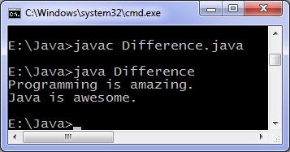

**import** java.lang.Math;

### Using static method of another classes

**class** Another {

**public** **static** **void** main(String[] args) {

**int** result;

result = Math.min(10, 20); *//calling static method min by writing class name*

System.out.println(result);

System.out.println(Math.max(100, 200));

}

}

Output of program:

10

200